Muller Amigo Plus Installation Instructions
Cover feeder 1580
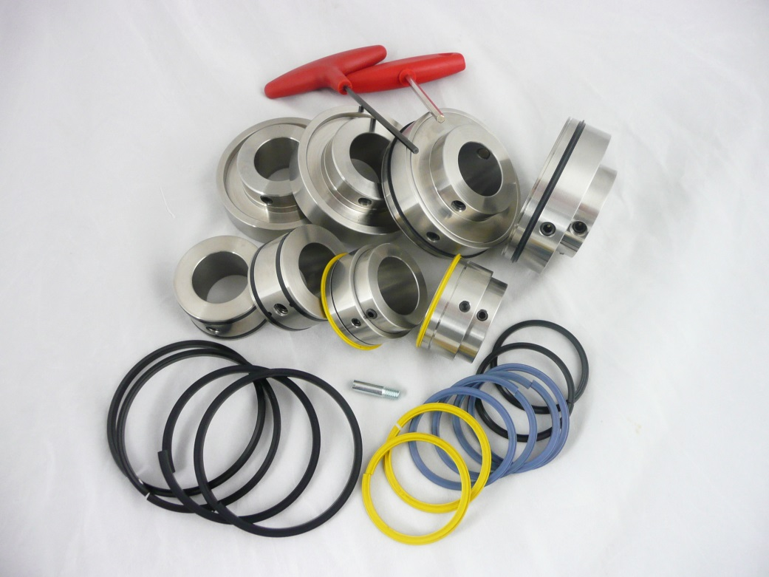

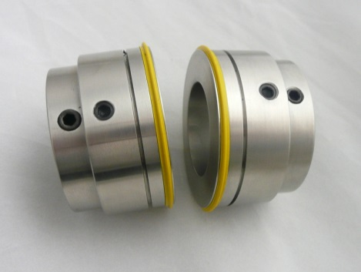
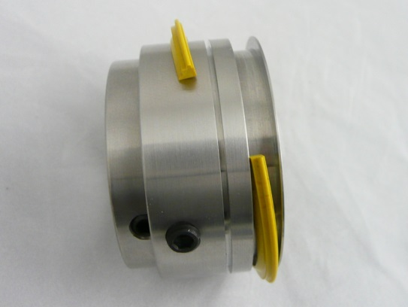
Top Shaft Parts

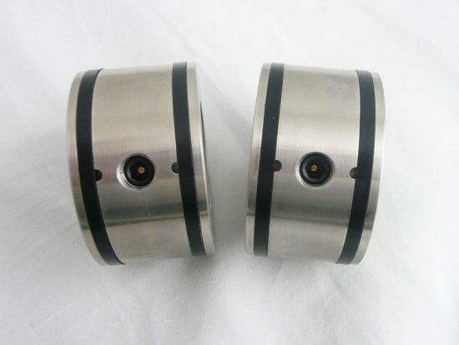
The top shaft creasing units are designed to form the spine crease.
To remove the coloured crease ribs loosen the holding screw with 3mm hexagon key and simply slide the retaining collar and remove the crease rib.
Place a gripper support collar at each side of the creasing collar.

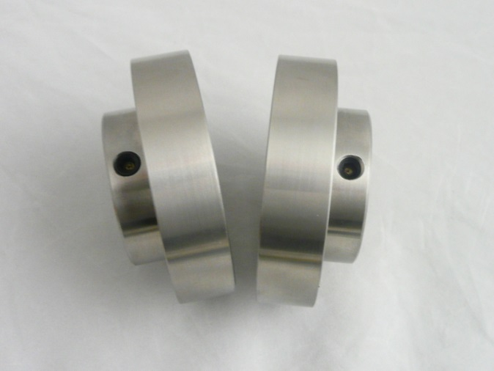
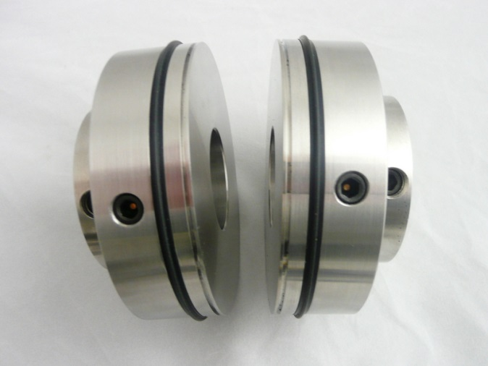
Bottom shaft
To obtain the correct amount of grip the large support collars must be place directly above the top shaft gripper supports collars
The large black rubber form the hinge

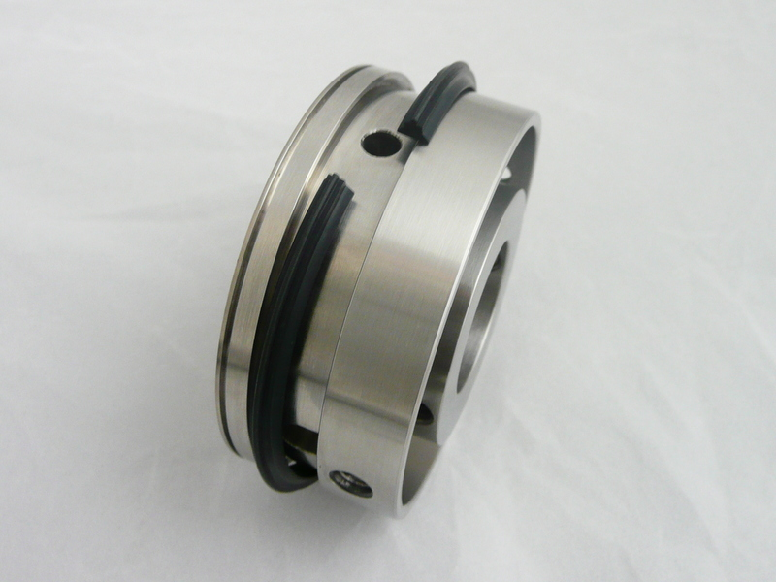
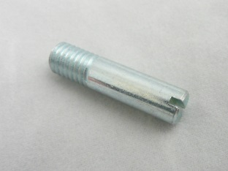
To secure the crease rib use the 2 x retaining collar screws
Inner shaft locating screw

Installing the bottom shaft parts

Align a bottom crease unit with the edge of the book clamp and tighten the fixing screws. Using the special locating screw to secure the crease unit onto the inner shaft, align the remaining bottom crease unit into the desired position and tighten the fixing screw.

Installing the top shaft parts

It is important to use the Technifold top & bottom gripper support collars.

Once the top shaft crease units are on the shafts insert the split crease ribs into the units.
As the top shaft is being lowered, slide the male crease rib protrusions into the corresponding female channels.

To achieve the correct grip between the support collars, align the top and bottom collars together. Place a sheet of thin paper (100gsm) between the support collars and gently lower the top shaft until a light grip is achieved on side is achieved.

Slowly run a sheet of cover stock between the crease units. As the cover stock rotates through the crease units the loosened top crease units automatically centralise to the optimum crease position. Tighten the top fixings screws when they rotate into view.

To achieve the optimum crease position the crease ribs must locate into the centre of the female channels.

Crease Rib Choices

4 x Blue Crease Ribs code (M-92)
stocks 100-250gsm

4 x Yellow Crease Ribs code ( M-91)
for stocks 250-350gsm

2 x Black Nylon Creasing Ribs
for laminated & 300-250gsm heavy stocks
code (QC-DEL-MPB/PC-B)

